**Rocky Mountain Neuroscience, Inc.**

**4521 South Seminal Street, San Diego, CA 92101 USA**

**Phone: (619)624-2322 Fax: (619)624-2323 Email: qeeg@rmsc.com**

**Quantitative EEG Analyses**

|  |  |
| --- | --- |
| **PATIENT INFORMATION** | **RECORDING** |
| **Name: Mr. TBI** | **Date: 04/19/2004** |
| **Exam#: TBI-001** | **Ref. By:** |
| **Age: 55.00** | **Test Site:** |
| **Gender:** | **Analysis Length: 01:59** |
| **Handedness:** | **Ave. SH Reliability: 0.99** |
| **Eyes: Closed** | **Ave. TRT Reliability: 0.95** |

**MEDICATION: Zolov, Dilatin**

**HISTORY: Struck by a bat in the right parietal lobe. CT scan showed an epidural hematoma that stopped bleeding during the night. Patient has left side spatial neglect, only shaves the left side of his face, rights on the left side of a page of paper and has paresis of the left leg and left arm.**

**SUMMARY: The qEEG analyses were deviant from normal and showed dysregulation in bilateral frontal lobes especially in the right frontal lobes, the bilateral temporal lobes and especially right temporal lobes, bilateral parietal lobes and especially the right parietal lobe and bilateral occipital lobes, especially in the right. LORETA showed dysregulation in the right fusiform gyrus, right lingual gyrus, right posterior insula, right inferior parietal and right superior temporal gyrus and right Postcentral gyrus. The temporal lobes are involved in auditory information processing, short-term memory, receptive language on the left and face recognition on the right. The parietal lobes are involved in visual-spatial information processing, short-term memory, executive attention, receptive language on the left and empathy control and awareness of emotional expression in others on the right (e.g., prosody). The occipital lobes are involved in the visual processing of color, form, movement, visual perception and spatial processing. The fusiform gyrus is involved in processing of color information, face and body recognition, word recognition, and within-category identification. The posterior insular cortex is involved in autonomic system regulation and interoceptive representation of the physiological condition of the body. The post central gyrus is involved in skilled motor movements and sensory-motor integration. To the extent there is deviation from normal electrical patterns in these structures, then sub-optimal functioning is expected**.

|  |
| --- |
|  |
| **Dr. Competent, Ph.D., QEEG-D, BCIA, ECNS** |

**DETAILED NARRATIVE**

**LINKED EARS: The Linked Ears power spectral analyses were deviant from normal with excessive power in bilateral frontal regions especially in the right frontal region over a wide frequency range, excessive power was present in bilateral temporal regions especially in the right temporal region over a wide frequency range, excessive power was present in bilateral parietal regions especially in the right parietal region over a wide frequency range and excessive power was also present in bilateral occipital regions especially in the right occipital region from 1 - 2 Hz.**

**SURFACE LAPLACIAN: The Laplacian power spectral analyses were deviant from normal with excessive power in bilateral frontal regions especially in the right frontal region over a wide frequency range, excessive power was present in bilateral temporal regions especially in the right temporal region at 1 Hz, excessive power was present in the right parietal region over a wide frequency range and excessive power was also present in bilateral occipital regions especially in the right occipital region over a wide frequency range.**

**NEUROIMAGING: LORETA 3-dimensional source analyses were consistent with the surface EEG and showed excessive current sources in the right Fusiform Gyrus and right Lingual Gyrus with a maximum at 2 Hz (Brodmann areas 37, 30 & 19). Elevated LORETA current source were present in the right Posterior Insula, right Inferior Parietal Lobule and right Superior Temporal Gyrus with a maximum at 3 Hz (Brodmann areas 13, 40 & 29). Elevated LORETA current source were present in the right Superior Temporal Gyrus, right Insula and right Transverse Temporal Gyrus with a maximum at 4 Hz (Brodmann areas 29, 13 & 41). Elevated LORETA current source were present in the right Inferior Parietal Lobule and right Superior Temporal Gyrus with a maximum at 5 Hz (Brodmann areas 40, 42 & 22). Elevated LORETA current source also were present in the right Inferior Parietal Lobule and right Postcentral Gyrus with a maximum at 6 Hz (Brodmann areas 40, 2 & 1).**

**CONNECTIVITY ANALYSES: EEG amplitude asymmetry, coherence and EEG phase were deviant from normal, especially in frontal, temporal, parietal and occipital relations. Elevated coherence was present in frontal, temporal, parietal and occipital regions which indicates reduced functional differentiation. Reduced coherence was present in frontal, temporal, parietal and occipital regions which indicates reduced functional connectivity. Both conditions are often related to reduced speed and efficiency of information processing.**

**DISCRIMINANT ANALYSES: The mild head injury discriminant function detected a pattern in the EEG that is commonly present in individuals with a history of mild traumatic brain injury.**

**NEUROFEEDBACK RECOMMENDATIONS: The following implications for neurotherapy are offered based upon the clinical evaluation of the patient as well as the reference data base results. These suggestions for neurotherapy should be evaluated with caution and should only be considered as possible strategies that the clinician may consider in his/her evaluation. If the patient is depressed, then the clinician should consider treating this condition first through alpha frequency enhancement or some other biofeedback protocol that may reduce depression. If depression or poor mood and/or motivation is not a problem then the clinician may consider using one or more strategies with the priority of treatment in the order presented below.**

**Linked Ears Z Score Neurofeedback**

**1- Suppress toward Z = 0 frequency activity 1 - 7 Hz at P4.**

**2- Suppress toward Z = 0 frequency activity 1 - 2 Hz at O2.**

**3- Suppress EEG coherence toward Z = 0 at 1 - 4 Hz between F8 and T3.**

**LORETA Z Score Neurofeedback**

**1- Suppress toward Z = 0 at 5 Hz, Right Brodmann area 40.**

**2- Suppress toward Z = 0 at 6 Hz, Right Brodmann area 40.**

**3- Suppress toward Z = 0 at 4 Hz, Right Brodmann area 29.**

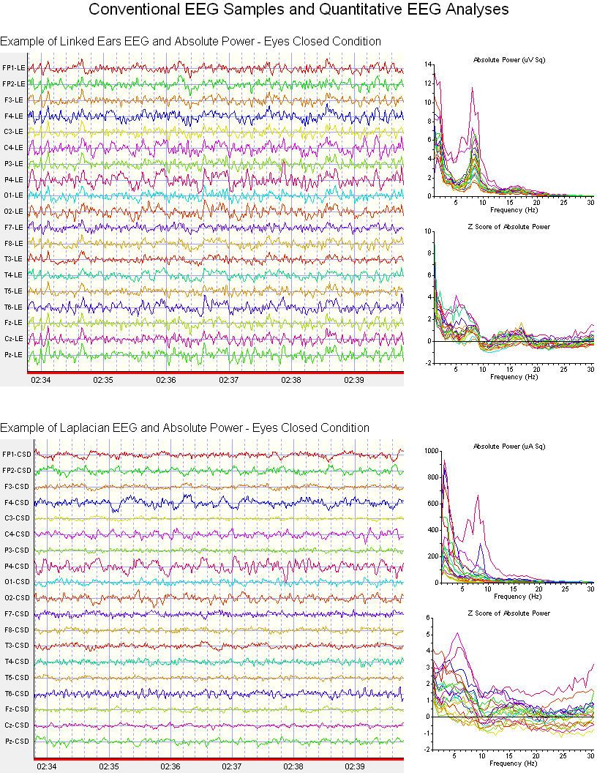

**Electrical NeuroImaging**

**Linking a patient's symptoms and complaints to functional systems in the brain is important in evaluating the health and efficiency of cognitive and perceptual functions. The electrical rhythms in the EEG arise from many sources but approximately 50% of the power arises directly beneath each recording electrode. Electrical NeuroImaging uses a mathematical method called an "Inverse Solution" to accurately estimate the sources of the scalp EEG (Pascual-Marqui et al, 1994; Pascual-Marqui, 1999). Below is a Brodmann map of anatomical brain regions that lie near to each 10/20 scalp electrode with associated functions as evidenced by fMRI, EEG/MEG and PET NeuroImaging methods.**

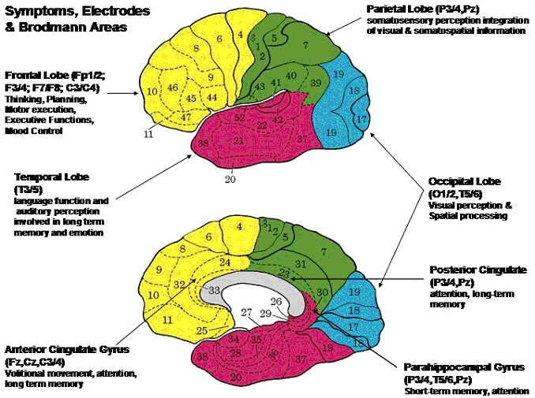

**BRAIN BRODMANN REGIONS**

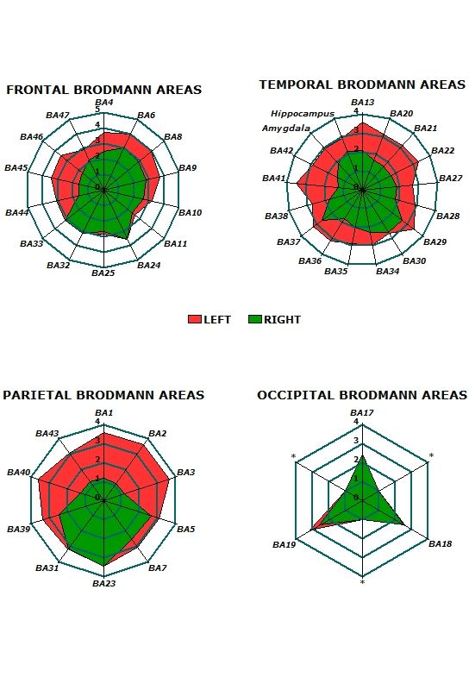

**Fig. 1 - Example of LORETA Z Scores at 2 Hz. (Brodmann areas 37, 30 & 19).**

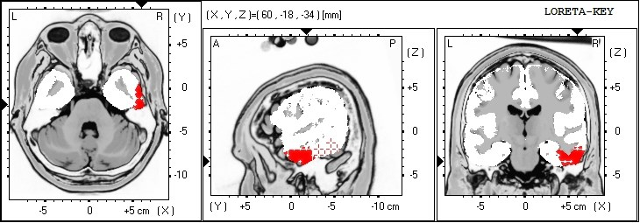

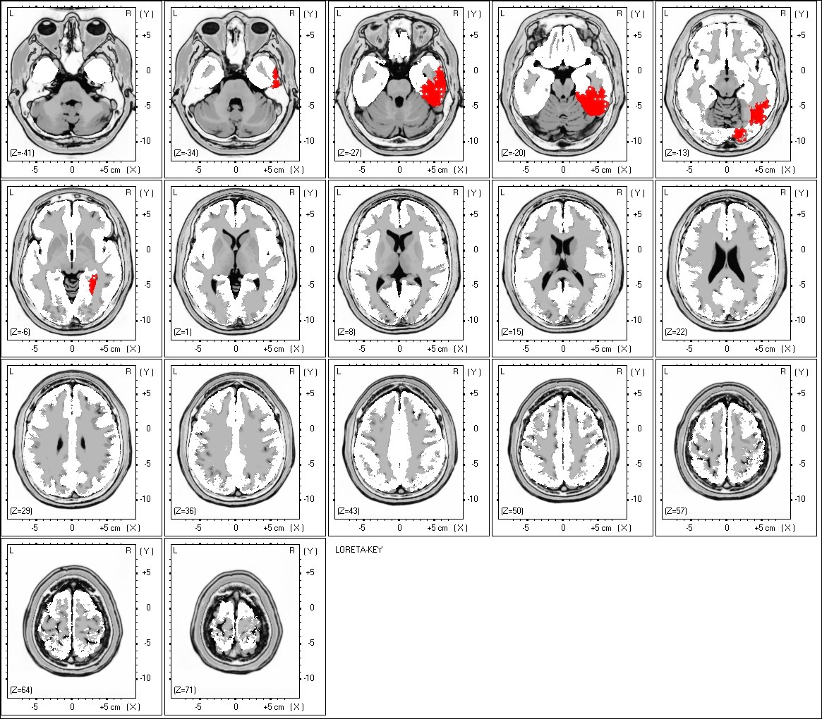

**Fig. 2 - Example of LORETA Z Scores at 3 Hz. (Brodmann areas 13, 40 & 29).**

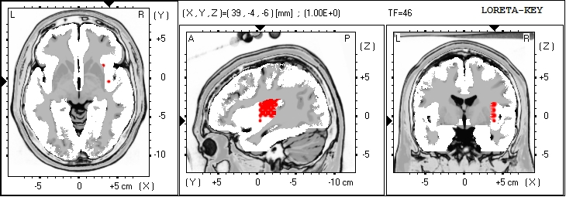

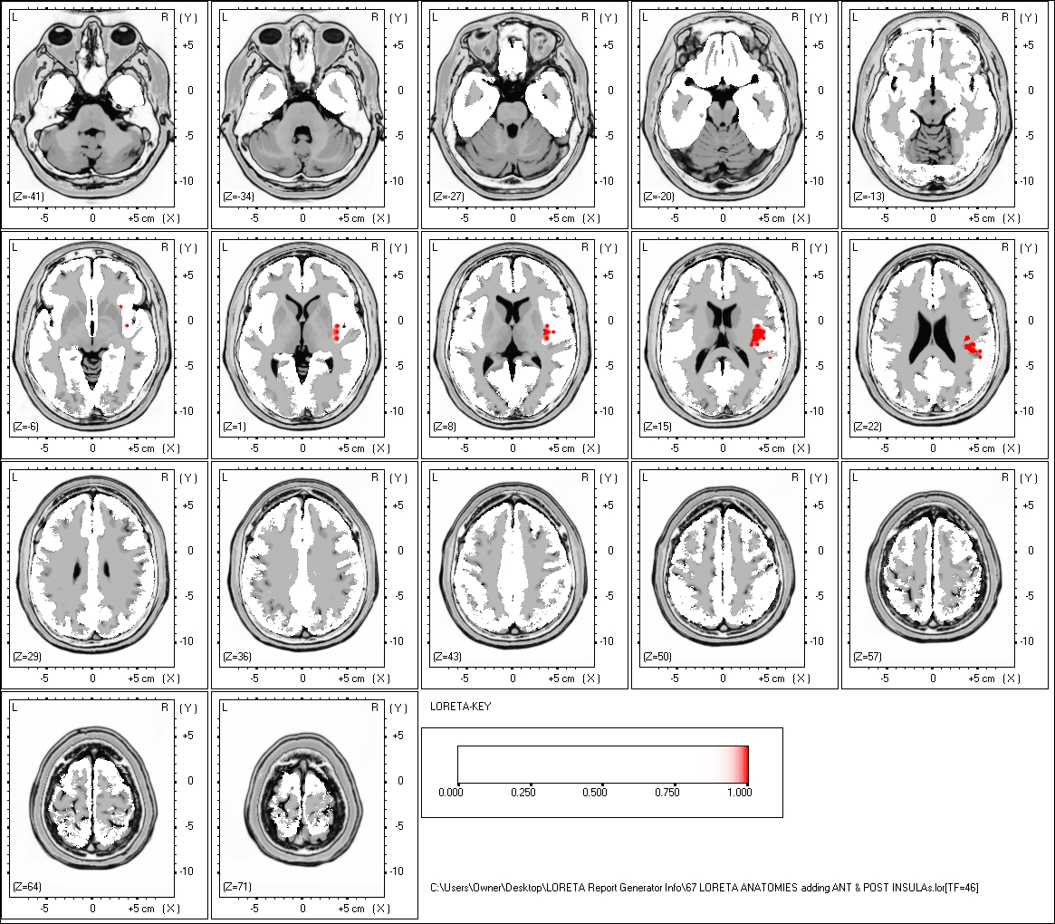

**Fig. 3 - Example of LORETA Z Scores at 4 Hz. (Brodmann areas 29, 13 & 41).**

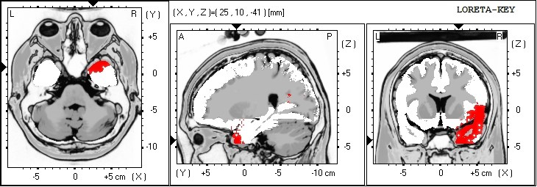

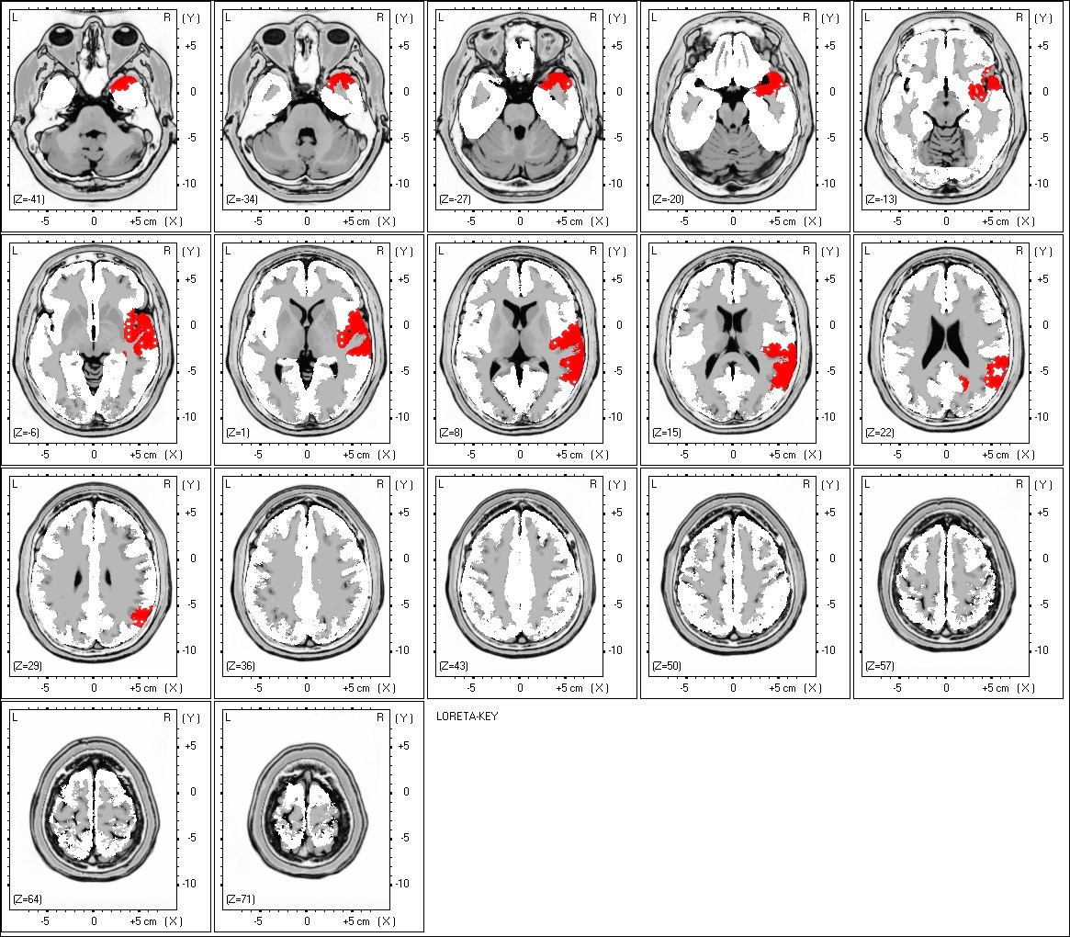

**Fig. 4 - Example of LORETA Z Scores at 5 Hz. (Brodmann areas 40, 42 & 22).**

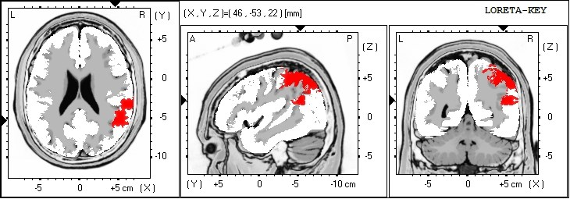

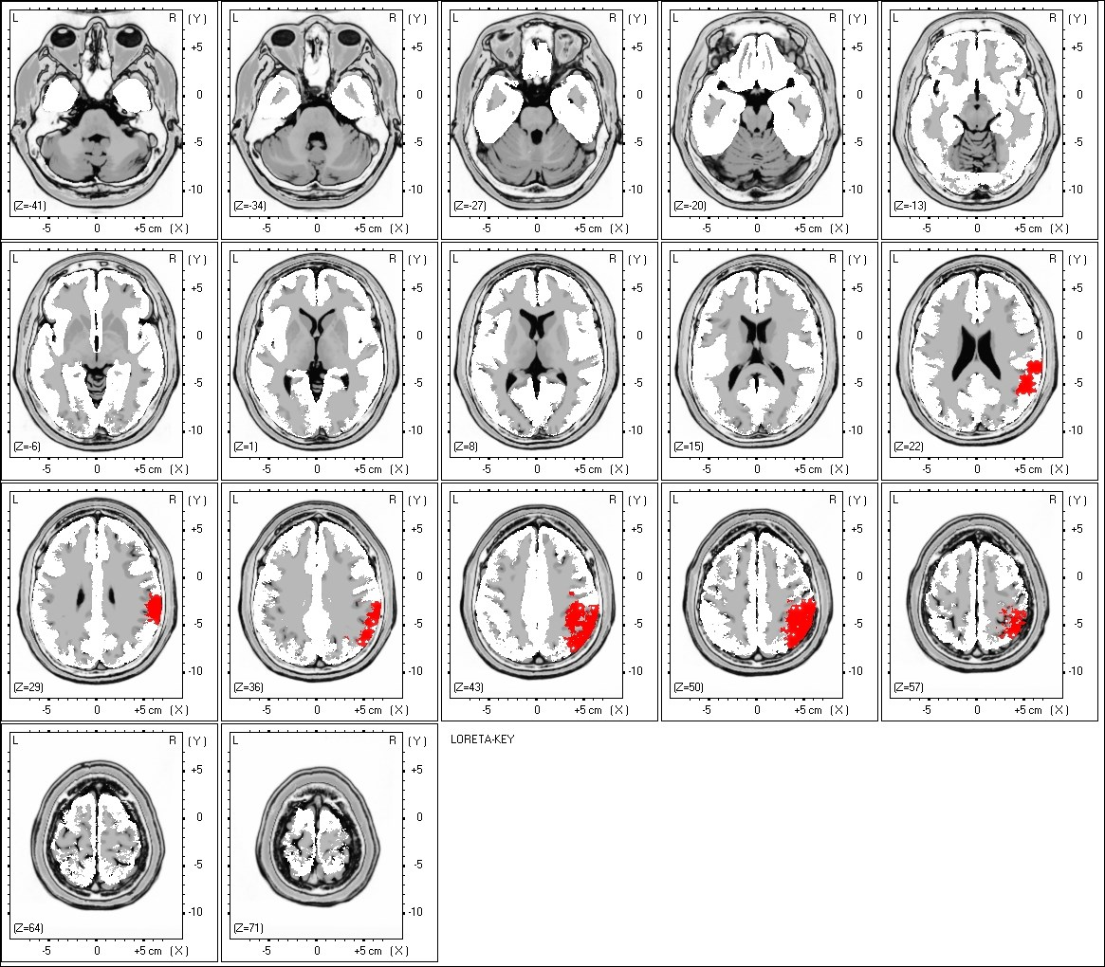

**Fig. 5 - Example of LORETA Z Scores at 6 Hz. (Brodmann areas 40, 2 & 1).**





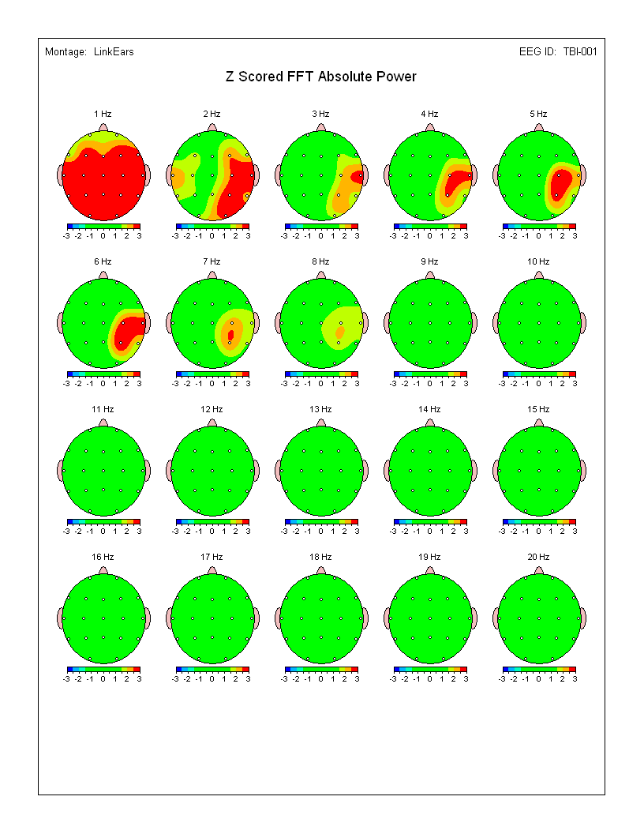

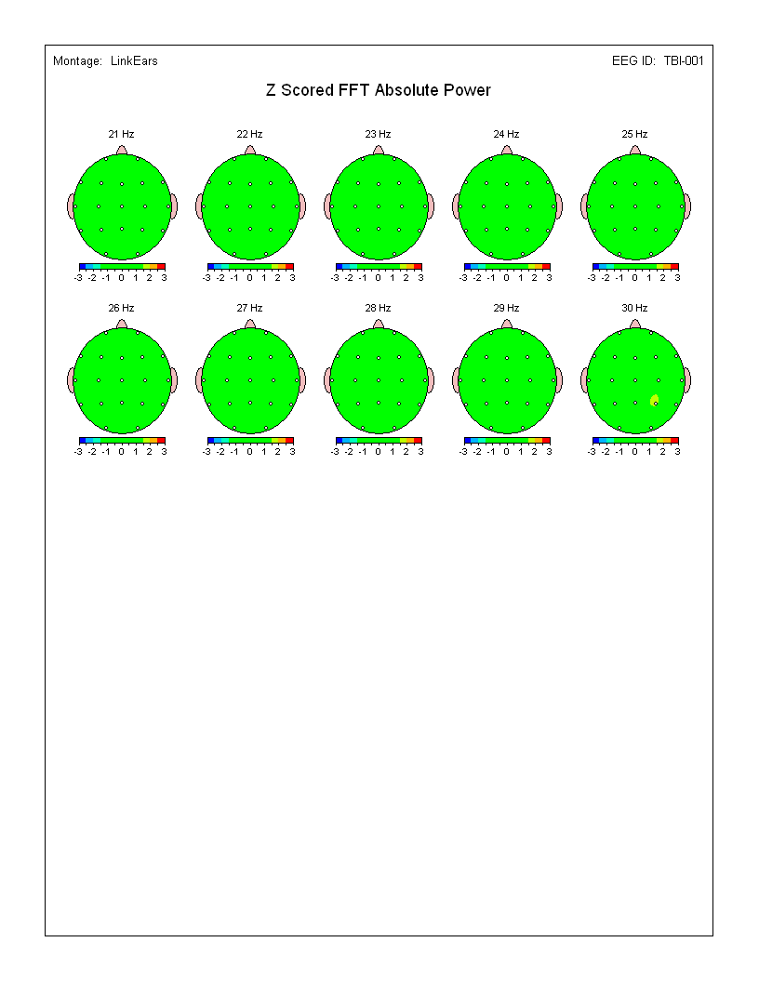

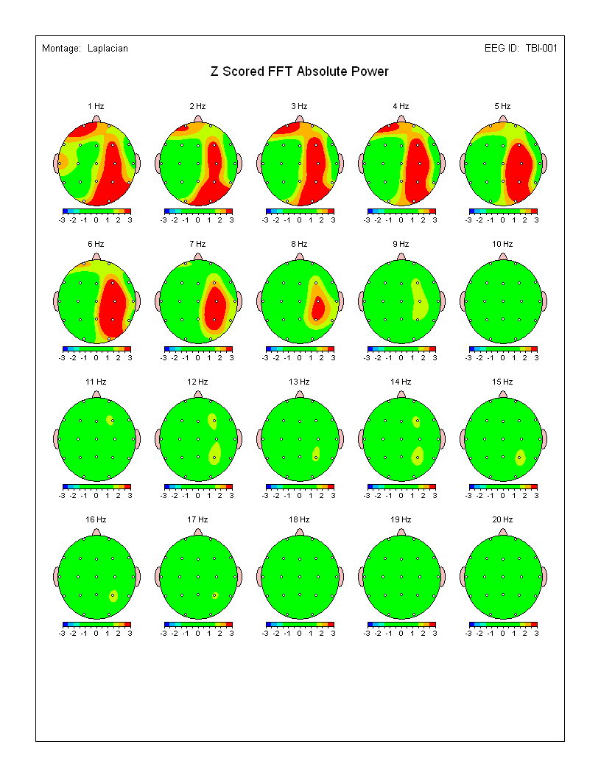

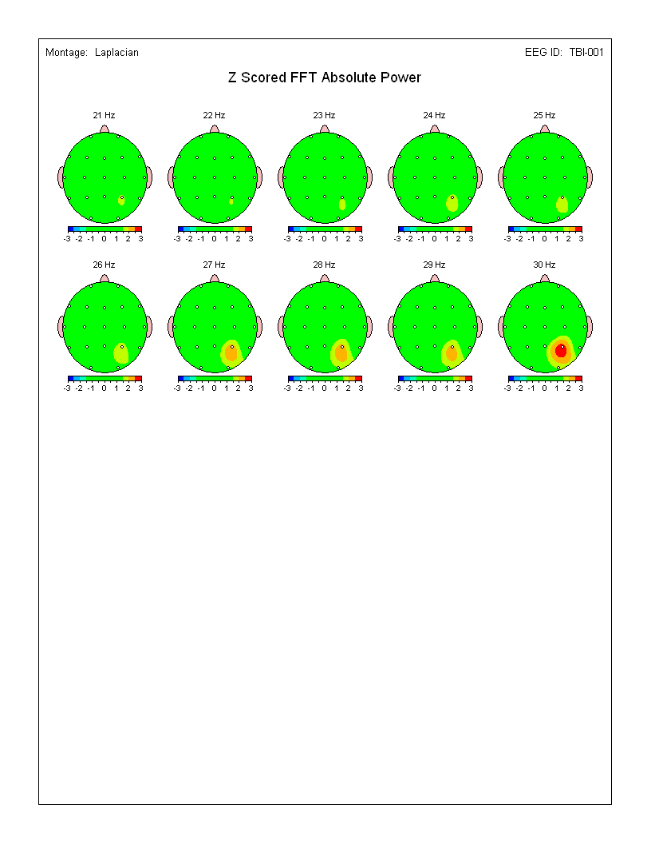

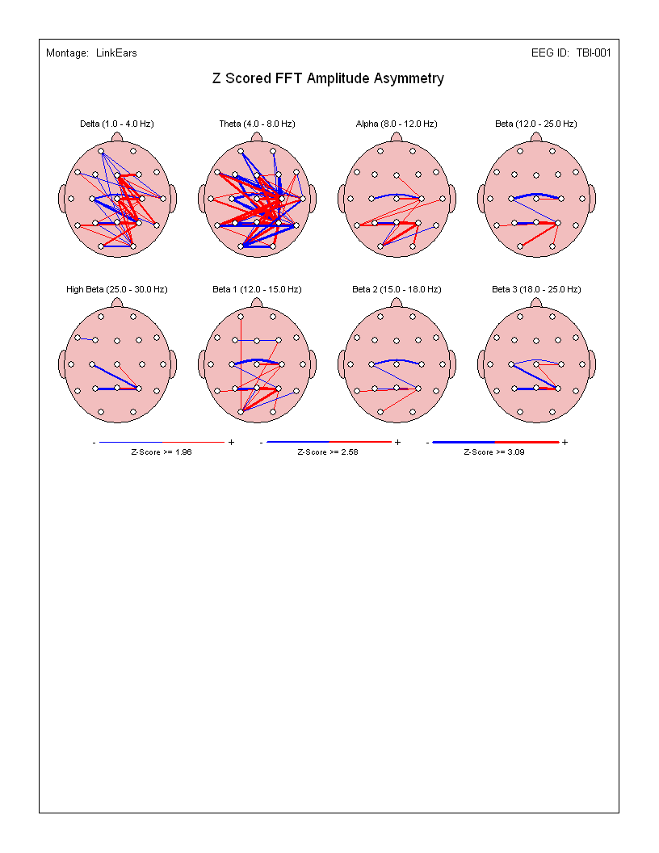

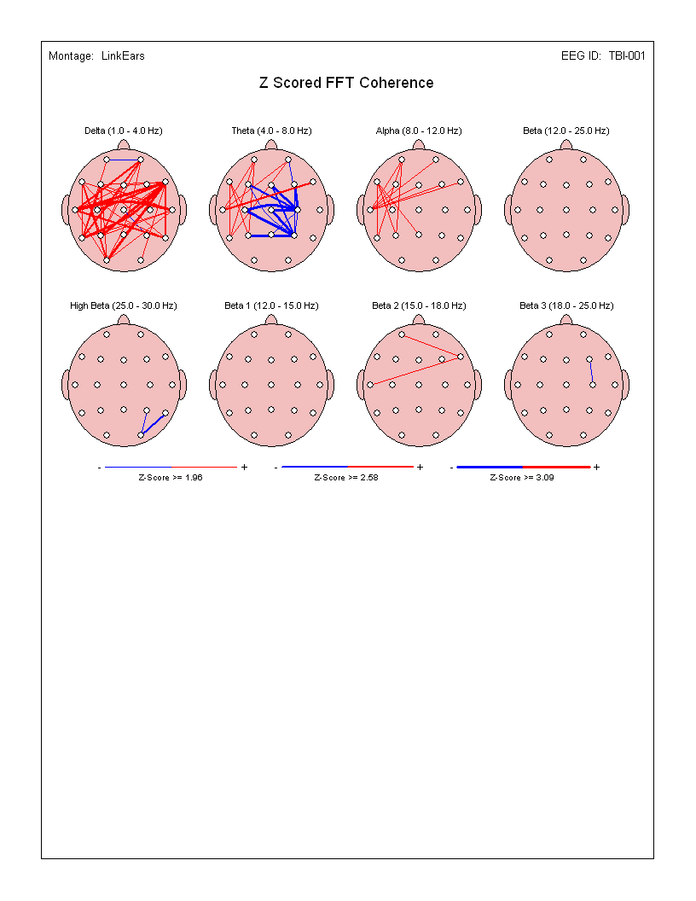

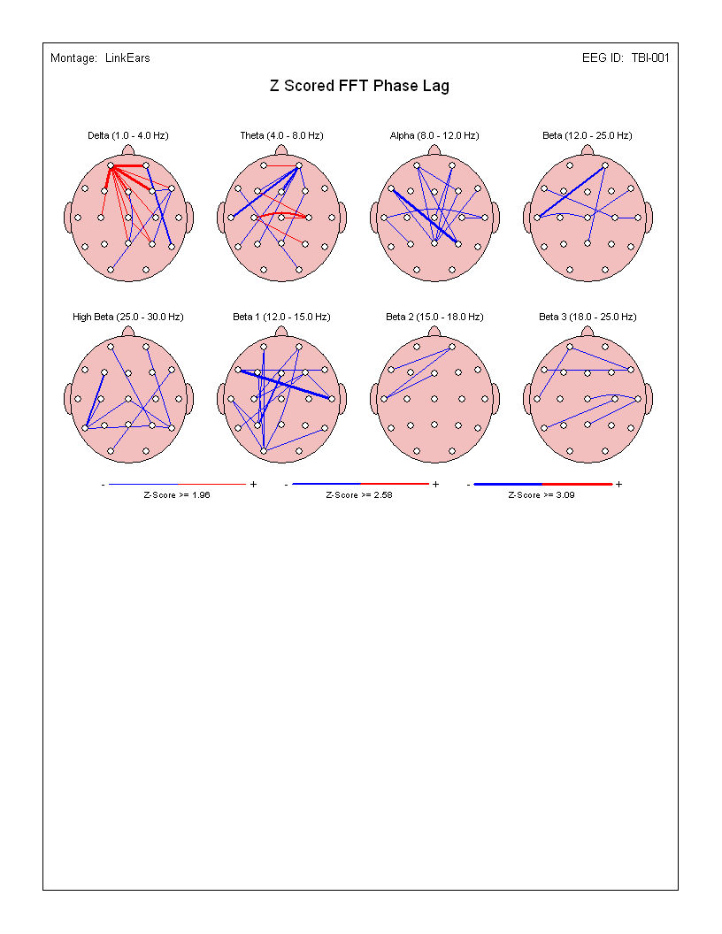

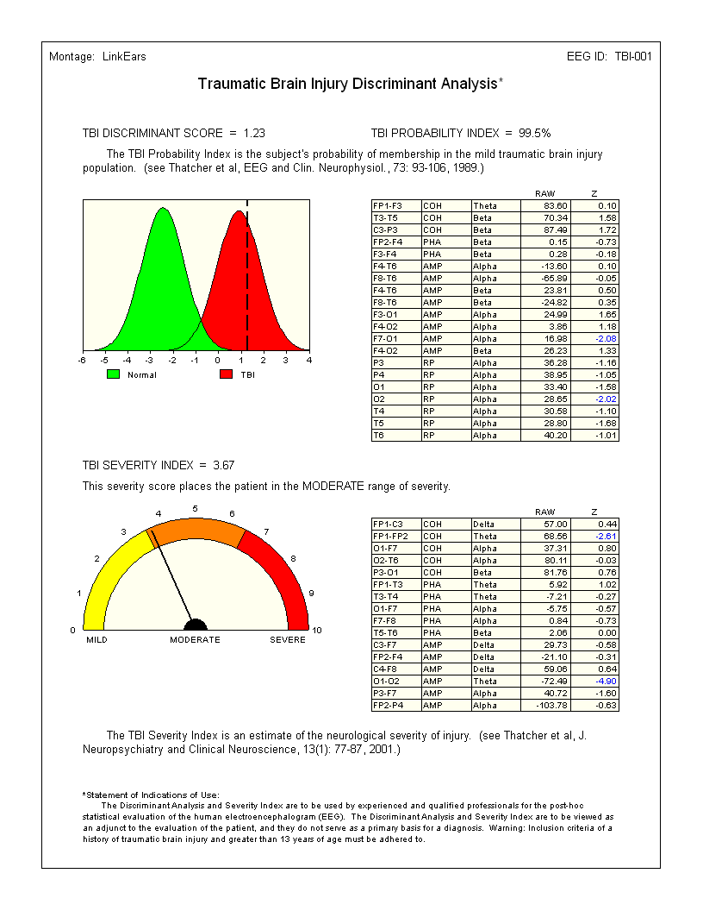

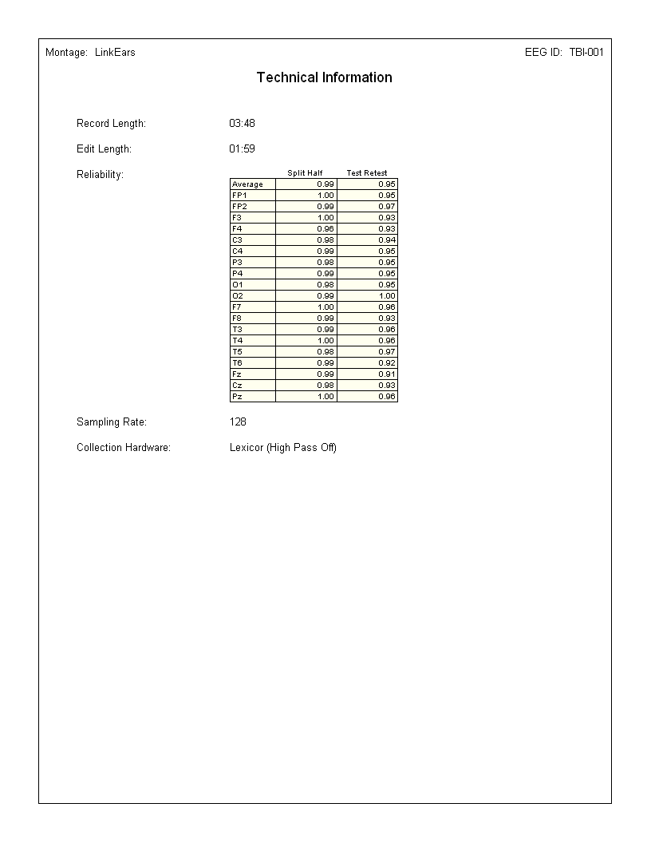

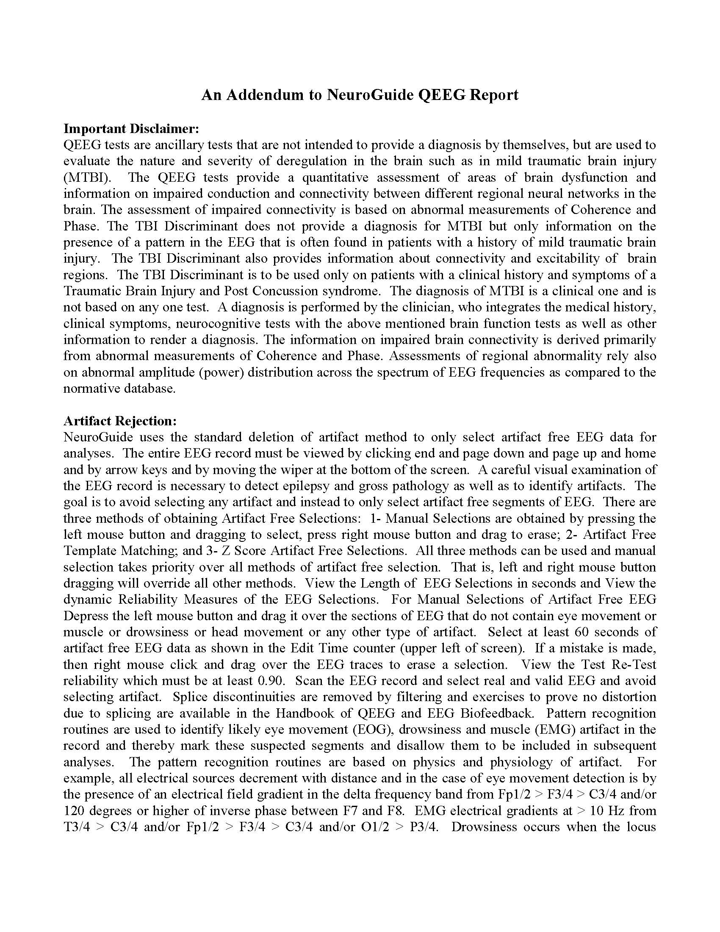

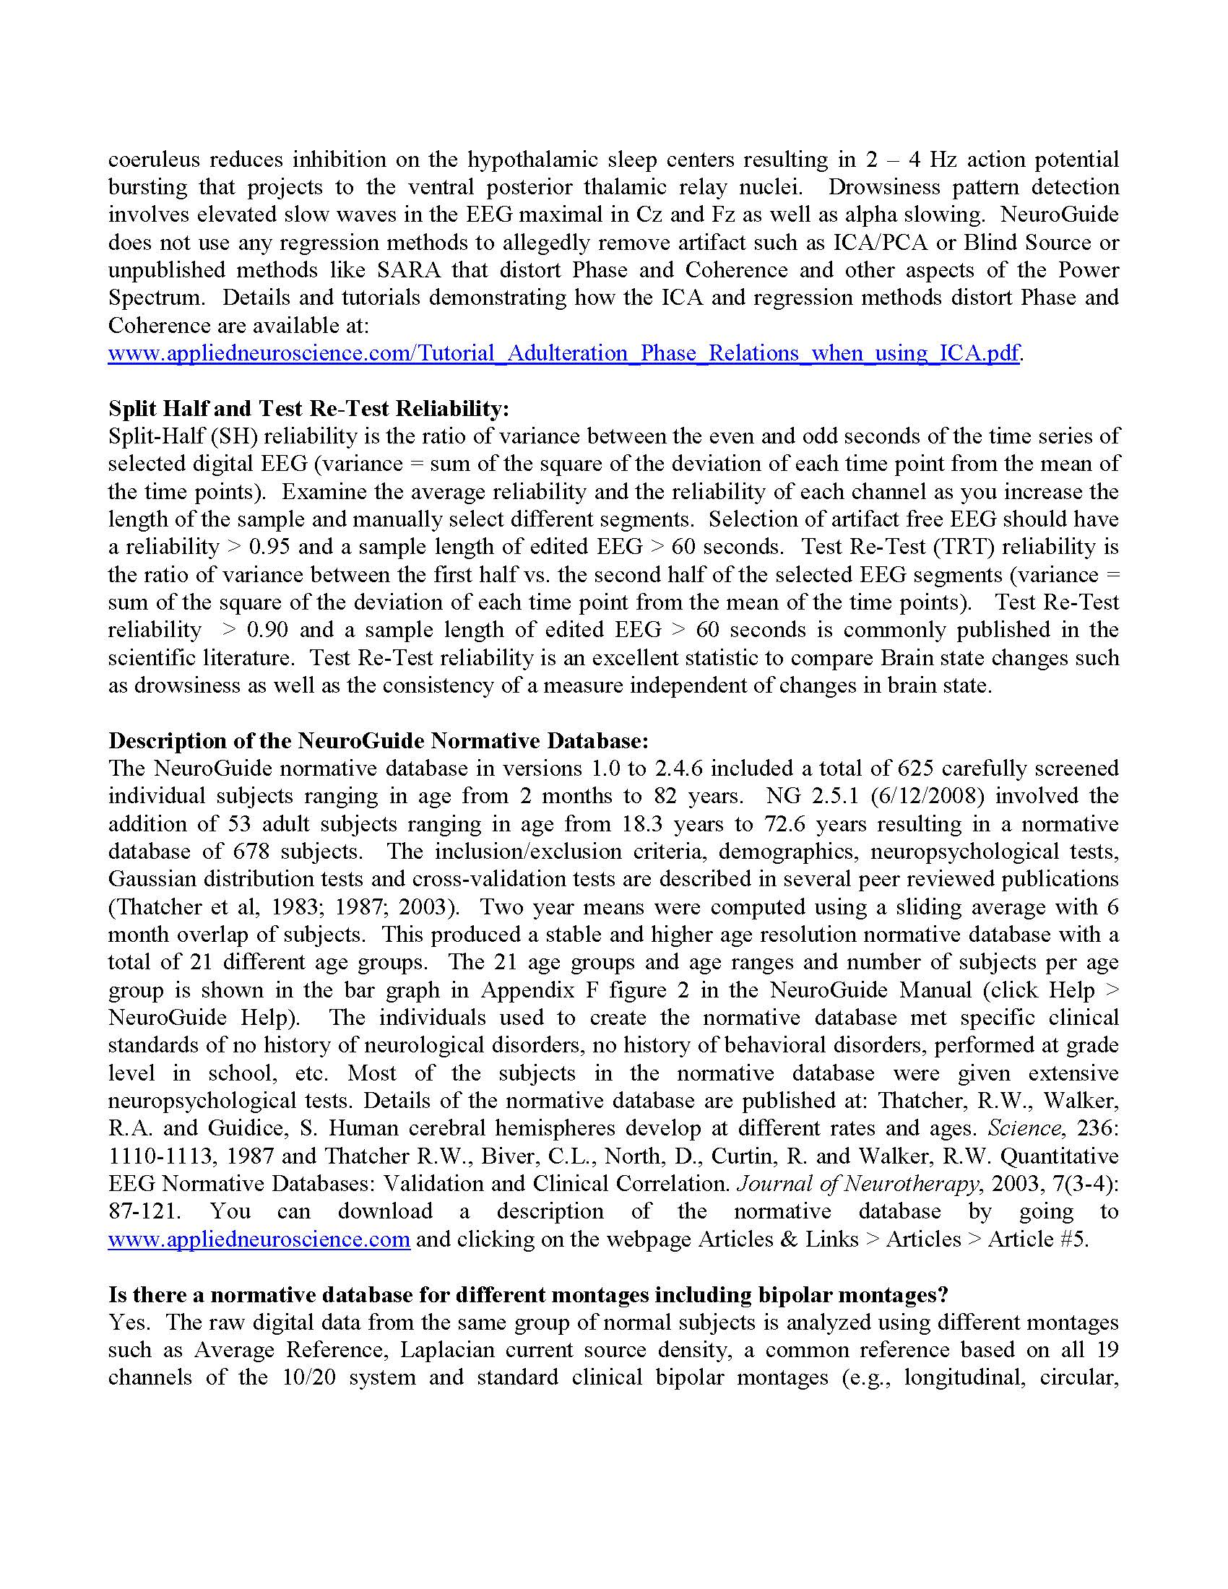

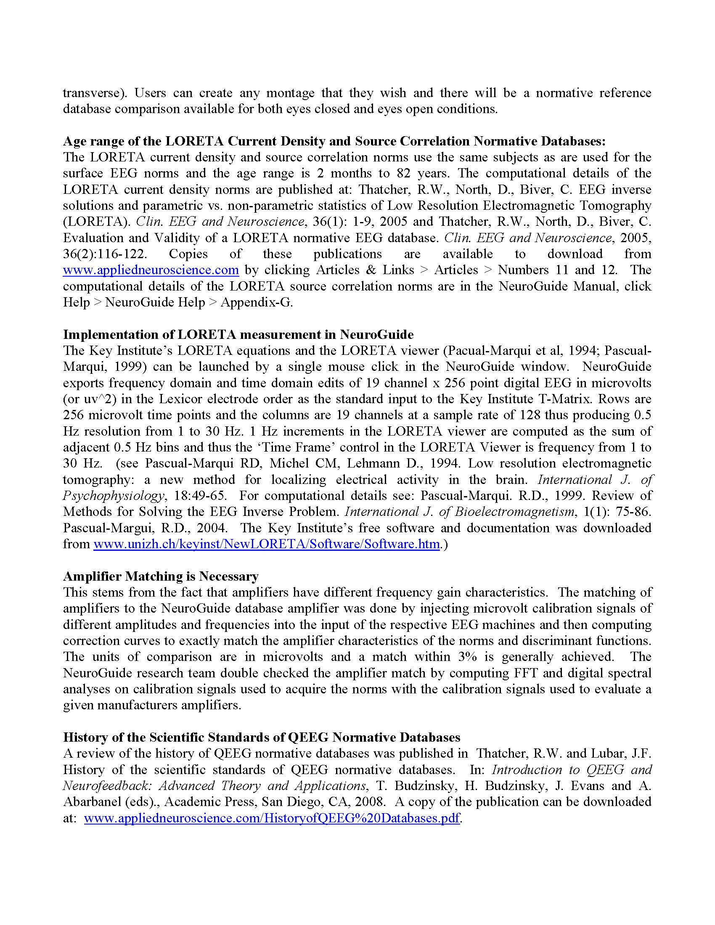

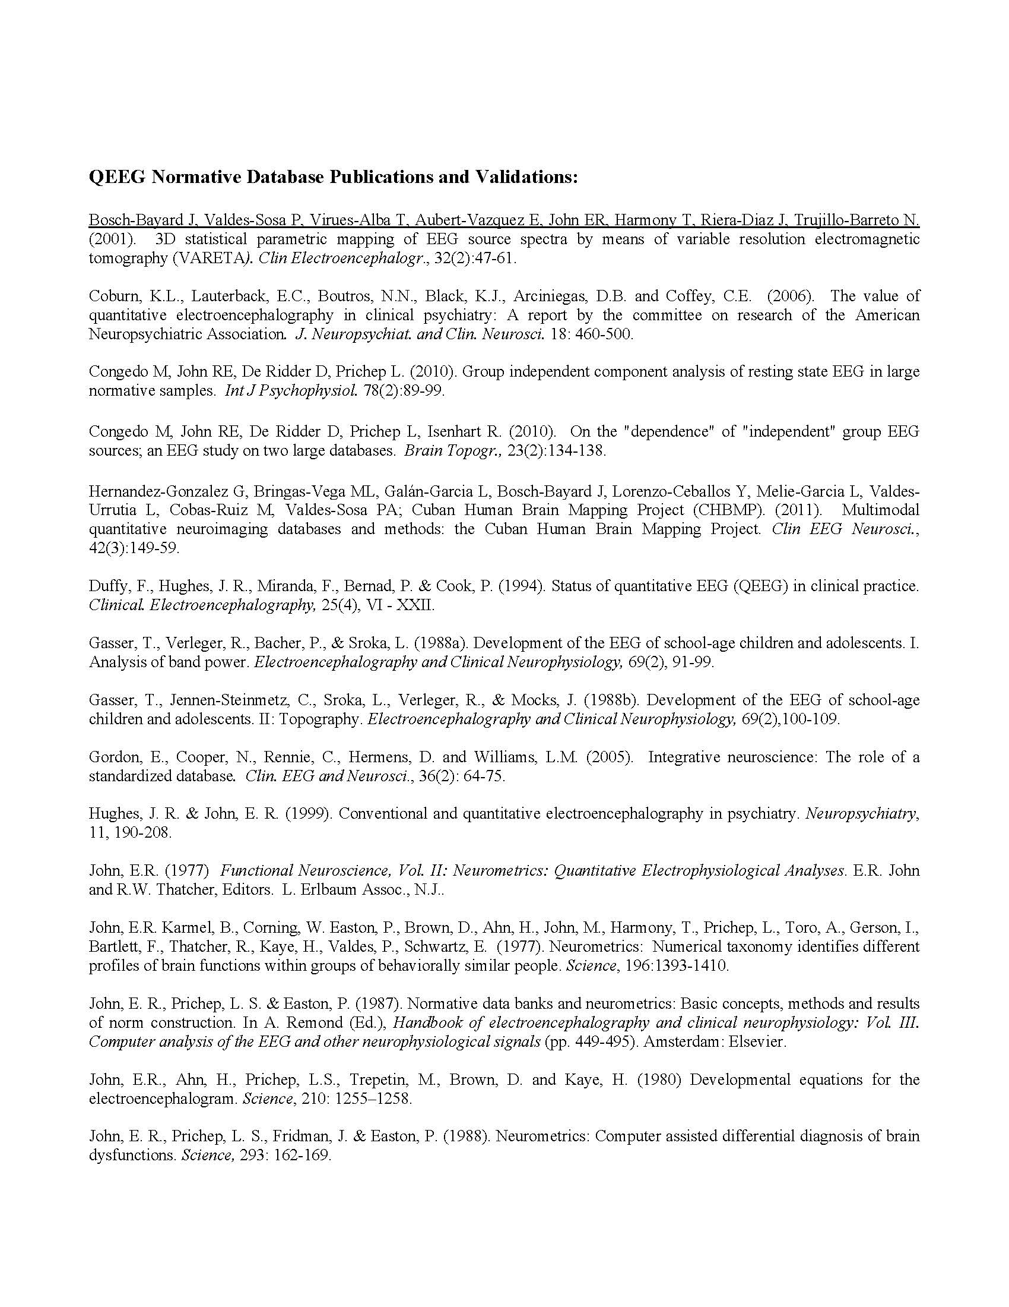

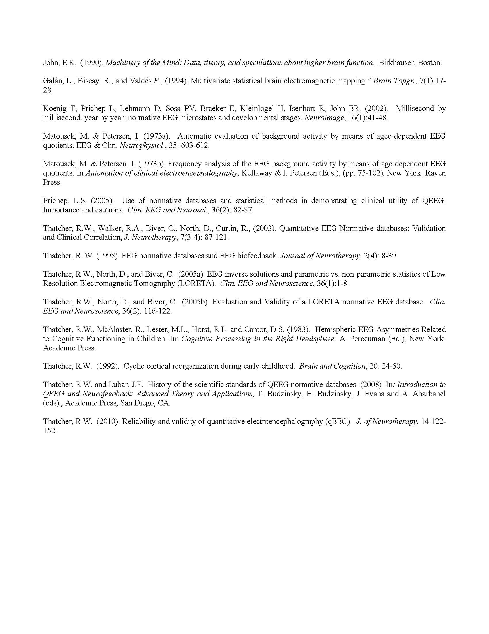

**Disclaimer: This template report (ACR) produced by Neuroguide software does not provide a diagnosis and only lists scientifically known functional linkages to parts of the brain that are significantly deviant from a reference normal population. Any diagnosis added to the report is the responsibility of the user of the ACR program and not ANI. The ACR assumes that only artifact free data were used in the analysis and proper scientific procedures were followed. Users of the ACR may make changes to the document and Applied Neuroscience, Inc. (ANI) is not liable or responsible for alterations that a user may make to the document. The accuracy of the analyses is totally dependent on the EEG recording amplifier and recording procedures and ANI is not responsible or liable for inadequate equipment used to record EEG or poor recording hygiene or if the user of this program is not using valid EEG data.**